

LAB EXPERIMENTS
ECA1011 Microprocessors and Microcontrollers

Submitted To:
Dr. EDWIN DHAS DHASON
Submitted By:
Name: DENISHASHREE R
Reg No: 192524124
Department: B.Tech AI & D

INDEX

S.No | Date | Title of Experiment | Page No
1. | 15/10/26 | EX 1: 8-bit and 16 bit Arithmetic Operations
2. | 15/10/26 | EX 2: Logical, Bit-manipulation And Shift  Operations
3.
4.
5.
6.
7.
8.
9.
10.

DATE: 15/10/2026

EXPERIMENT 01: ANALYSIS, DEVELOPMENT AND VERIFICATION OF 8-BIT AND 16-BIT ARITHMETIC OPERATIONS USING ASSEMBLY LANGUAGE PROGRAM

Objective:
- To analyze, develop & verify 8-bit Addition and Subtraction
- To analyze, develop & verify 16-bit Addition and Subtraction
- To analyze, develop & verify 8-bit Multiplication and Division
- To analyze, develop & verify 16-bit Multiplication and Division

Components Required:
8085 Simulator or 8085 Intel Microprocessor

Procedure:
- Switch ON the 8085-microprocessor kit or open the 8085 simulator.
- Enter the program opcodes into the specified starting memory address using the memory examine/substitute command.
- Store the required input data in the specified memory locations, if provided.
- Execute the program from the given starting address using the GO/EXEC command.
- Examine the memory locations assigned for the results.
- Record the output values and verify them with the expected arithmetic results.
- Repeat the procedure for all four programs and record the observations.

  - Analysis of 8-bit Addition and Subtraction :

PROGRAM [Addition]
MVI C 00h LDA 4200h MOV B A LDA 4201h ADD B
JNC SKIP INR C
SKIP : STA 4202h MOV A C
STA 4203h HLT

OUTPUT
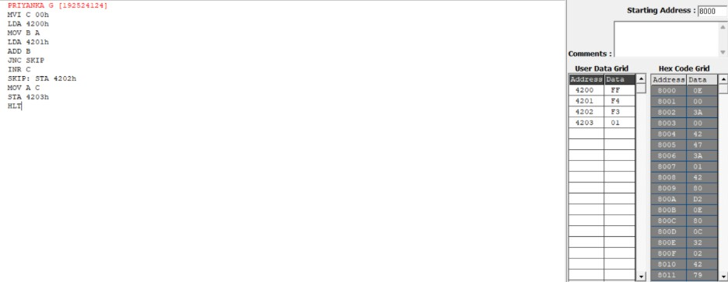

Memory | Data
4200 | FF
4201 | F4
4202 | F3
4203 | 01

PROGRAM [Subtraction]
MVI C 00h LDA 4201h MOV B A LDA 4200h SUB B
JNC SKIP CMA
INR A
INR C
SKIP : STA 4202h MOV A C
STA 4203h HLT

OUTPUT

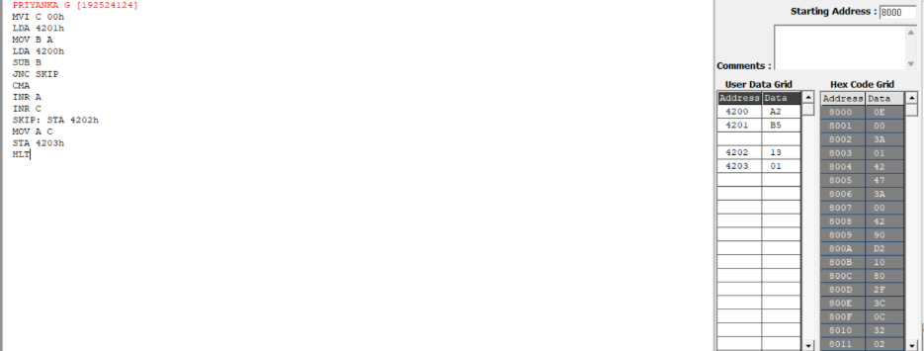

Memory | Data
4200 | A2
4201 | B5
4202 | 13
4203 | 01

  - Analysis of 16-bit Addition and Subtraction:

PROGRAM [Addition]
LHLD 4510 XCHG LHLD 4512 DAD D SHLD 4514
MVI A 00 JNC SKIP MVI A 01
SKIP: STA 4516 HLT

OUTPUT
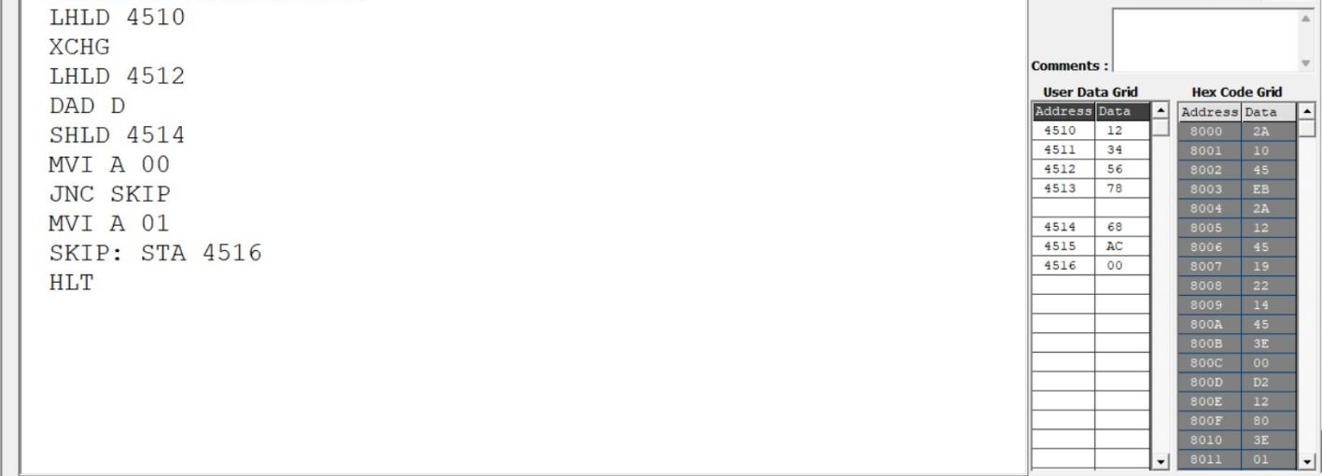

Memory | Data
4210 | 12
4211 | 34
4212 | 56
4213 | 78
4216 | 68
4217 | AC
4218 (carry) | 00

PROGRAM [Subtraction]
LDA 4510 MOV C A LDA 4511 MOV B A LDA 4512 SUB C STA 4516
LDA 4513 SBB B STA 4517
MVI A 00H JNC SKIP MVI A 01
SKIP: STA 4518 HLT

OUTPUT
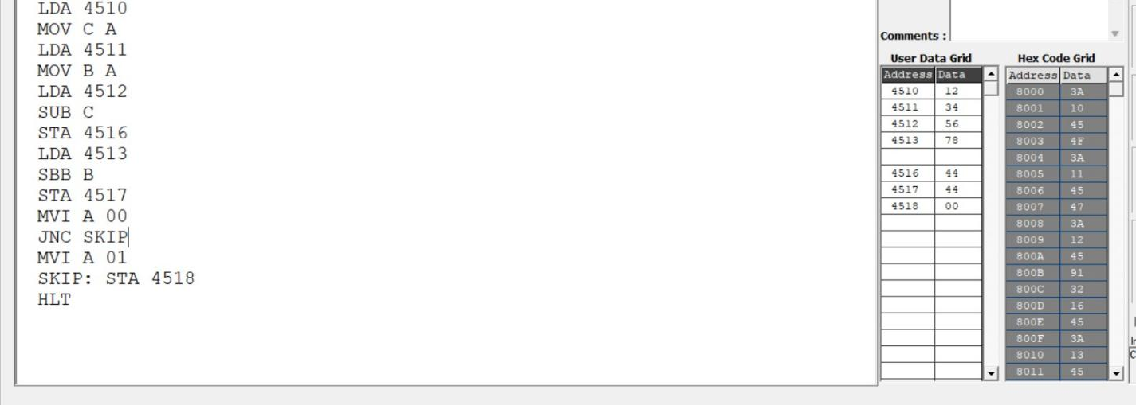

Memory | Data
4210 | 12
4211 | 34
4212 | 56
4213 | 78
4216 | 44
4217 | 44
4218 (carry) | 00

  - Analysis of 8-bit Multiplication and Division:

PROGRAM [Multiplication]
LXI H 0000H LDA 4201h MOV E A LDA 4202 MOV C A
REPEAT : DAD D DCR C
JNZ REPEAT SHLD 4203 HLT

OUTPUT
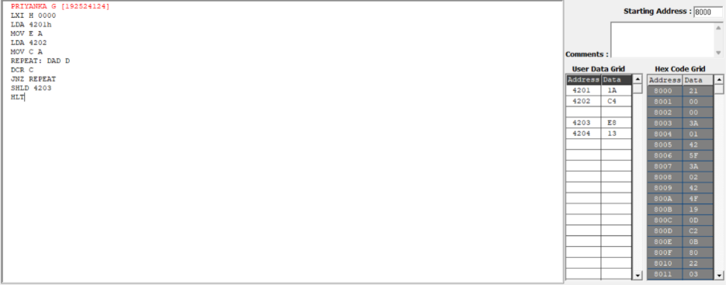

Memory | Data
4201 | 1A
4202 | C4
4203 | E8
4204 | 13

PROGRAM [Division]
LDA 4201h MOV E A LDA 4200h MOV B A MOV A E MVI C 00h
AGAIN: CMP B JC STORE SUB B
INR C
JMP AGAIN STORE: STA 4203h MOV A C
STA 4202h HLT

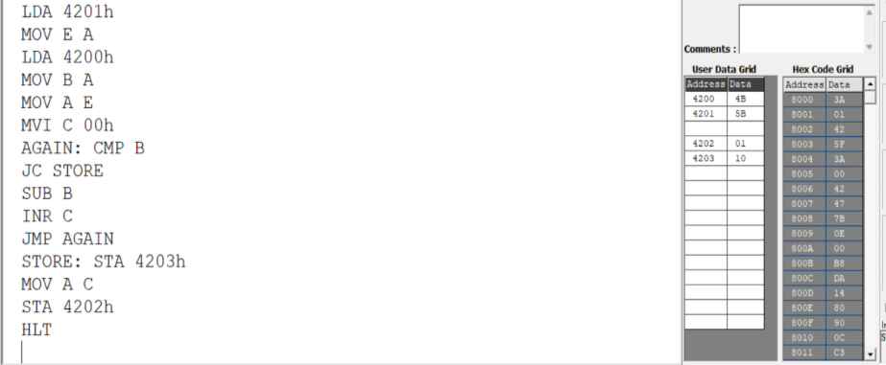
OUTPUT

Memory | Data
4200 | 4A
4201 | 5B
4202 | 01
4203 | 10

  - Analysis of 16-bit Multiplication and Division:

PROGRAM [Multiplication]
LXI H 4520
MVI M 00 INX H MVI M 00 INX H MVI M 00 INX H MVI M 00
LHLD 4500 XCHG LHLD 4502 MOV B H MOV C L
LOOP: MOV A B
ORA C JZ DONE
LHLD 4520 DAD D SHLD 4520 JNC SKIP LHLD 4522 INX H SHLD 4522
SKIP: DCX B JMP LOOP DONE: HLT

OUTPUT
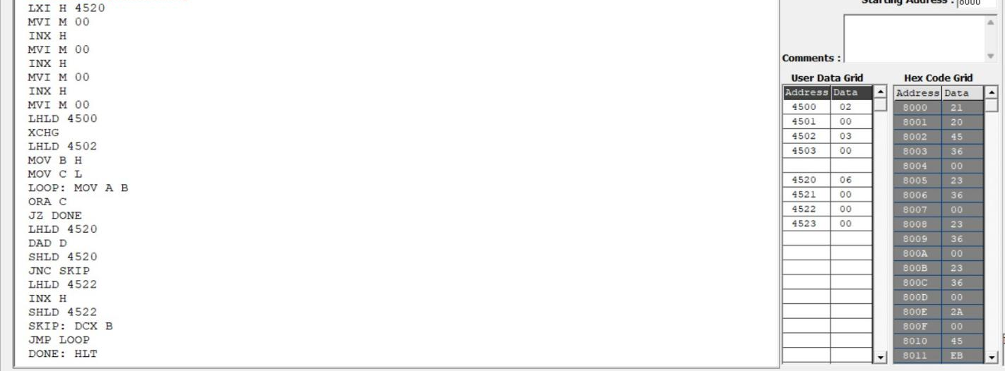

Memory | Data
4500 | 02
4501 | 00
4502 | 03
4503 | 00
4520 | 06
4521 | 00
4522 | 00
4523 | 00

PROGRAM [Division]

LXI H 0000
SHLD 4514
LHLD 4510 XCHG DIVLOOP: LHLD 4512 MOV A E SUB L MOV E A MOV A D SBB H MOV D A JC DONE XCHG SHLD 4510 XCHG
LDA 4514
INR A STA 4514
JNZ DIVLOOP
LDA 4515 INR A
STA 4515
JMP DIVLOOP DONE:
XCHG SHLD 4516 HLT

OUTPUT
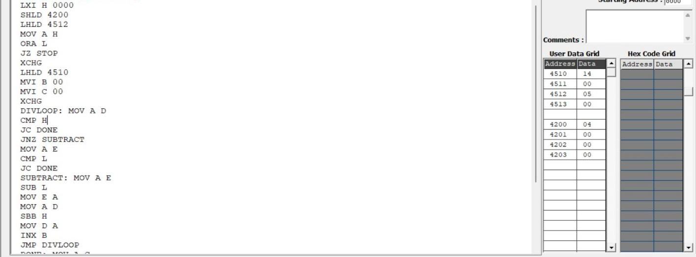

Memory | Data
4510 | 14
4511 | 00
4512 | 05
4513 | 00
4200 | 04
4201 | 00
4202 | 00
4203 | 00

Result:
Thus, 8-bit and 16-bit addition, subtraction, multiplication, and division programs were executed successfully using the 8085 microprocessors, and the results were verified by examining the specified memory locations and flag conditions.

DATE: 15/10/2026

EXPERIMENT 02: LOGICAL, BIT-MANIPULATION AND SHIFT OPERATIONS USING 8-BIT AND 16-BIT DATA

Objective:
- To analyze, develop and verify logical AND, OR and XOR operations.
- To analyze, develop and verify one's and two's complement operations on 8-bit and 16-bit data.
- To analyze, develop and verify bit setting, clearing, toggling, rotate and shift operations.
- To verify the output results and carry flag using the 8085 simulator.

Components Required:
8085 Simulator

Procedure:
- Switch ON the 8085-microprocessor trainer kit.
- Enter the program opcodes at the specified starting memory address using the memory examine/substitute command.
- Store the required input data in the specified memory locations.
- Execute Program A from 4100H and Program B from 4200H using the GO/EXEC command.
- Examine the memory locations assigned for the output results and flag byte.
- Record the output values and verify them against the expected hexadecimal results.
- Repeat the procedure for both programs and record the observations.

  - Analysis of Logical Operations

PROGRAM [AND,OR,XOR in 8-bit ]
LXI H, 4500H MOV A, M INX H
MOV B, M ANA B PUSH PSW STA 4502H POP H MOV A, L STA 4509H LDA 4500H ORA B
STA 4503H LDA 4500H XRA B
STA 4504H HLT

OUTPUT
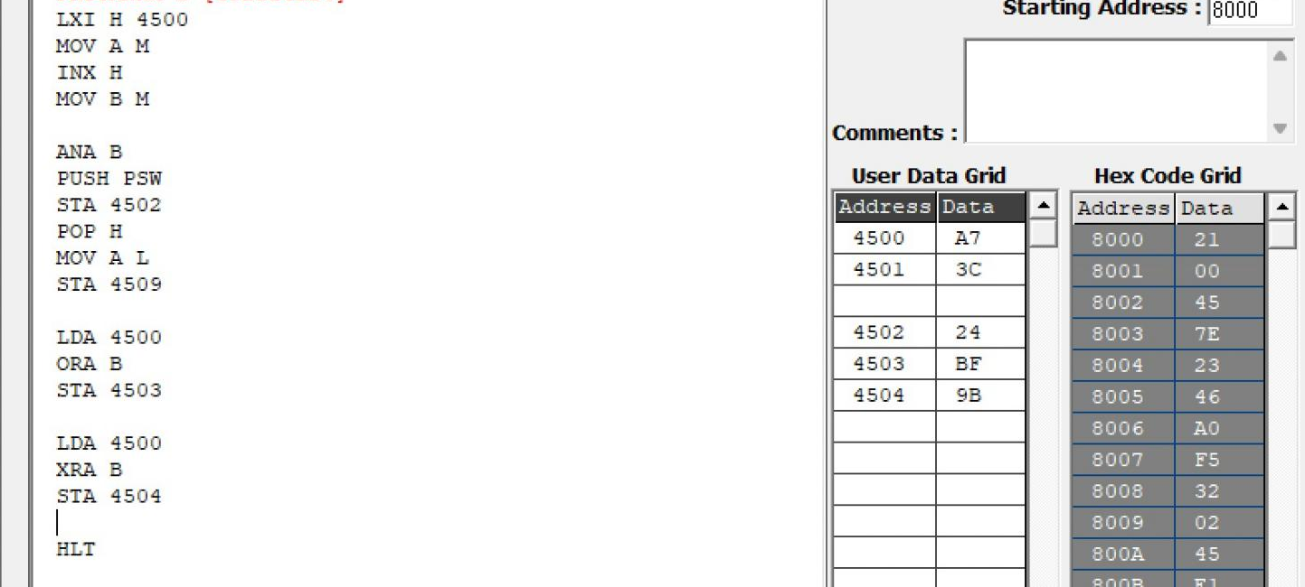

Memory | Data
4500H | A7H

4501H | 3CH
4502H | 24H
4503H | BFH
4504H | 9BH

PROGRAM [AND,OR,XOR in 16-bit ]
LDA 4500 MOV B A LDA 4502 ANA B STA 4504
LDA 4501 MOV B A LDA 4503 ANA B STA 4505
LDA 4500 MOV B A LDA 4502H ORA B STA 4506
LDA 4501
MOV B A LDA 4503 ORA B STA 4507
LDA 4500 MOV B A LDA 4502 XRA B STA 4508
LDA 4501 MOV B A LDA 4503 XRA B STA 4509 HLT

OUTPUT
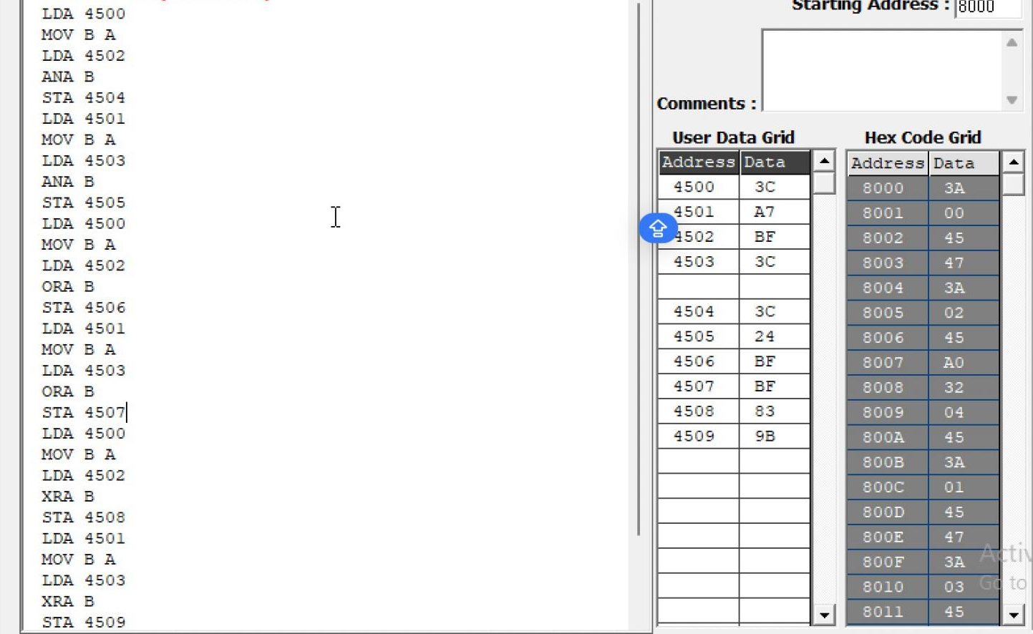

Memory | Data
4500 | 3CH
4501 | A7H
4502 | BFH
4503 | 3CH
4504 | 3CH
4505 | 24H
4506 | FFH
4507 | BFH
4508 | 83H
4509 | 9BH

  - Analysis of One's and Two's Complement

PROGRAM [16-bit]
LDA 4500H ANI 0FH STA 4505H LDA 4500H ANI F0H STA 4506H LDA 4500H CMA
STA 4507H INR A
STA 4508H
LHLD 450AH MOV A, L CMA
MOV L, A
MOV A, H CMA MOV H, A
SHLD 450CH INX H
SHLD 450EH HLT

OUTPUT
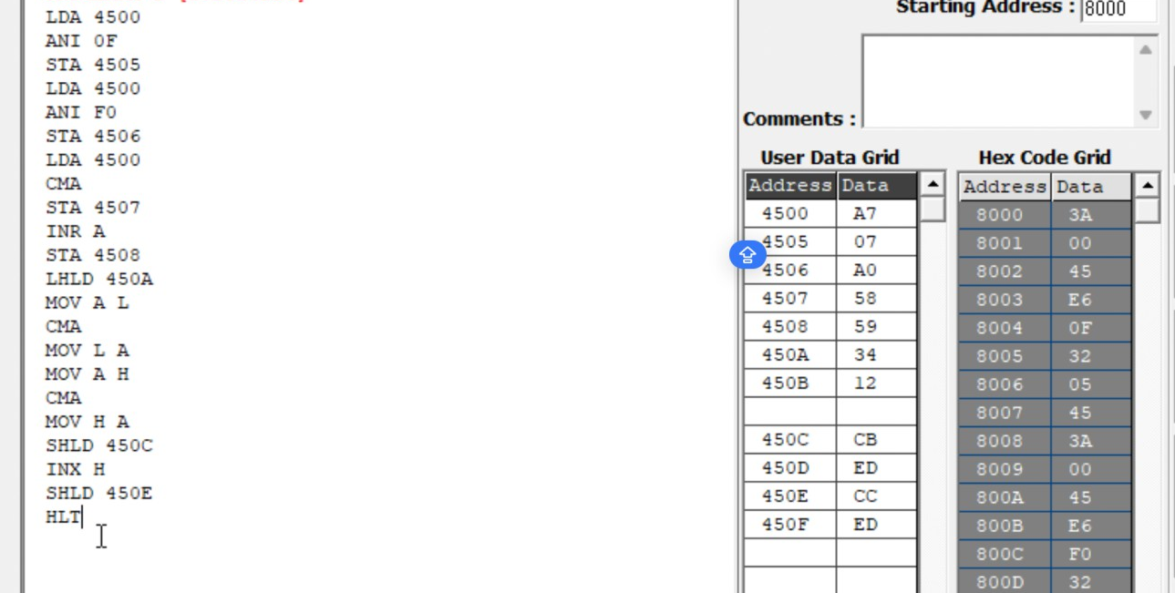
Memory | Data
4500 | A7
4505 | 07
4506 | A0
4507 | 58
4508 | 59
450A | 34
450B | 12
450C | CB
450D | ED
450E | CC
450F | ED

  - Analysis of Bit Setting, Clearing, Rotate

PROGRAM [Bit Manipulation]
LDA 4510H ORI 81H STA 4511H LDA 4510H ANI F5H STA 4512H LDA 4510H XRI 0FH STA 4513H MVI C, 00H LDA 4510H ANI 40H
JZ NEXT INR C
NEXT: MOV A, C
STA 4514H LDA 4510H RLC
STA 4515H LDA 4510H RRC
STA 4516H LDA 4510H ORA A
RAL
STA 4517H LDA 4510H ORA A
RAR
STA 4518H LDA 4510H MOV B, A RAL
MOV A, B RAR
STA 4519H LDA 4510H MVI B, 08H MVI C, 00H CNT: RLC

JNC SKIP INR C
SKIP: DCR B JNZ CNT MOV A, C STA 451AH HLT

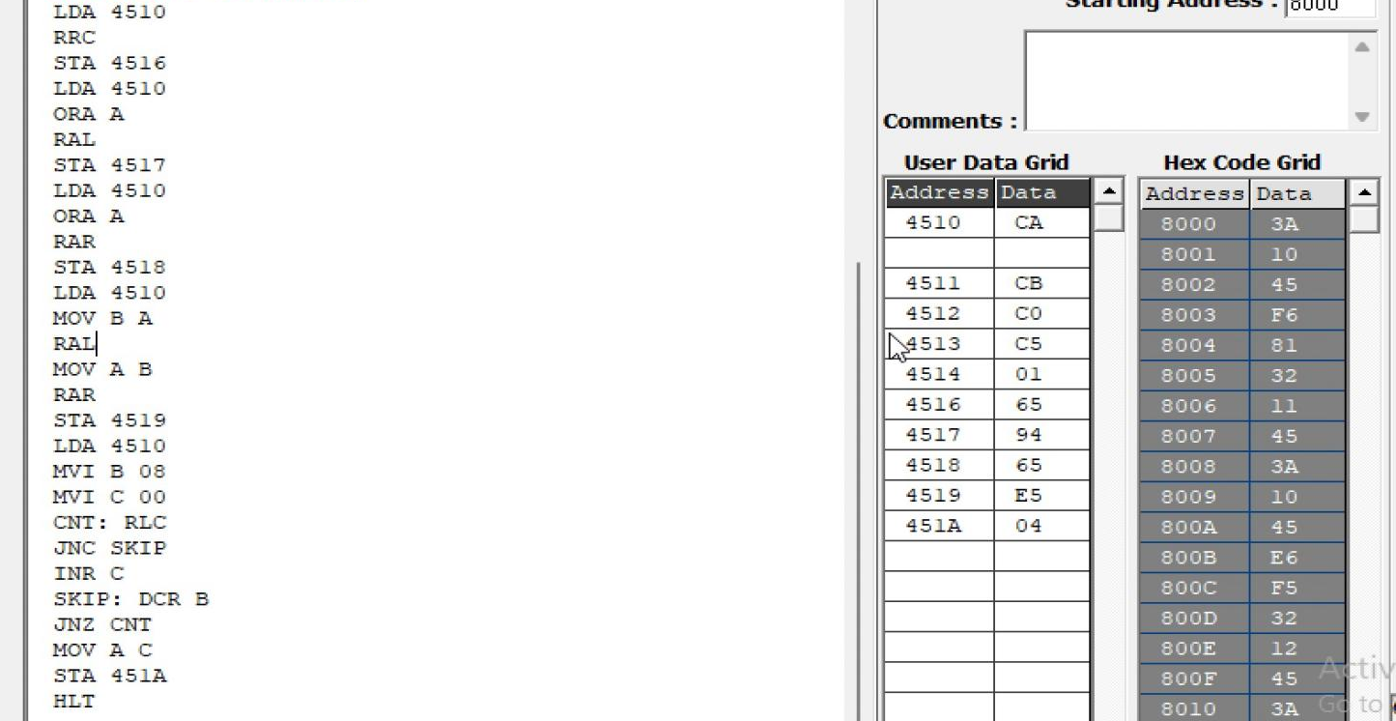
OUTPUT

Memory | Data
4510H | CAH
4511H | CBH
4512H | C0H
4513H | C5H
4514H | 01H
4515H | 95H
4516H | 65H
4517H | 94H
4518H | 65H
4519H | E5H
451AH | 04H

  - Analysis of Shift Operations

PROGRAM [16-bit Shift Left]
LHLD 4520H DAD H
SHLD 4522H HLT

OUTPUT
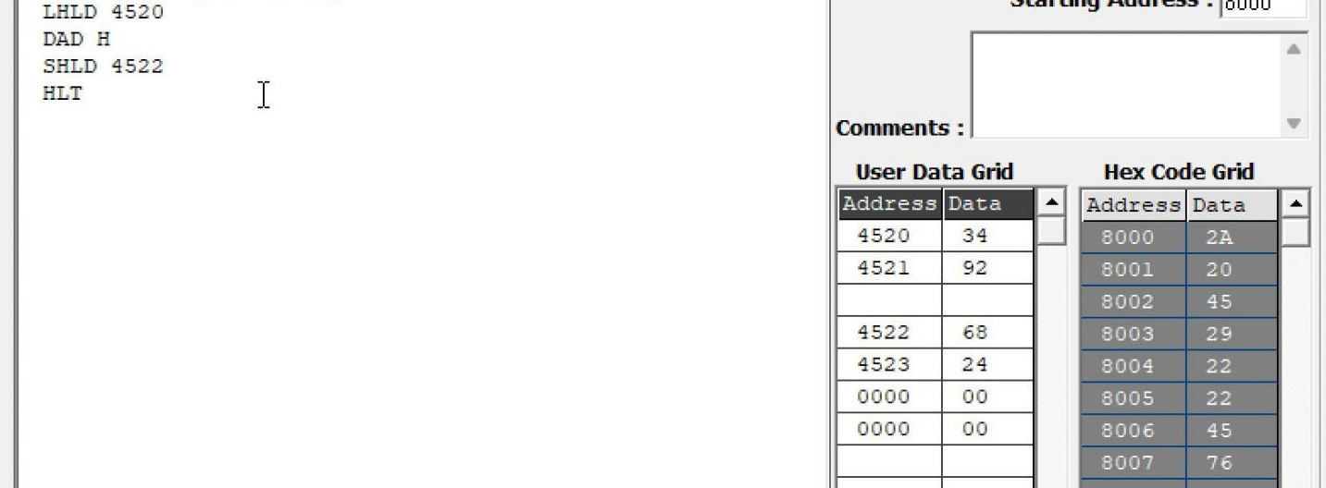

Memory | Data
4520H | 34H
4521H | 92H
4522H | 68H
4523H | 24H

Result:
Thus, the logical, bit-manipulation, complement, rotate and shift operations were performed using the 8085 simulator. The output values were examined in memory and verified against the expected hexadecimal results.

